**ST. XAVIER’S COLLEGE**

**(Affiliated to Tribhuvan University)**

Maitighar, Kathmandu



**COMPUTER GRAPHICS**

**LAB ASSIGNMENT #07**

**Submitted by:**

Rojesh Tamrakar

013BSCCSIT032

**Submitted to:**

|  |  |
| --- | --- |
| **Er. Anil K. Sah** |  |

Lecturer

Department of Computer Science

Date of submission: 1st September, 2015

# STATEMENT: Write a program to translate, rotate and scale the following image.

# SOURCE CODE:

//---------------------------------------------------------------------------

#include <vcl\vcl.h>

#include <math.h>

#pragma hdrstop

#include "Unit1.h"

//---------------------------------------------------------------------------

#pragma resource "*.dfm"

TForm1 *Form1;

//---------------------------------------------------------------------------

__fastcall TForm1::TForm1(TComponent* Owner)

: TForm(Owner)

{

}

//---------------------------------------------------------------------------

void __fastcall TForm1::Button1Click(TObject *Sender)

{

int x,y;

int a,b,tx,ty,i,j;

x=Image1->Height;

y=Image1->Width;

tx=StrToInt(Edit1->Text);

ty=StrToInt(Edit2->Text);

for(i=0;i<=x;i++)

{

for(j=0;j<=y;j++)

{

a=i+tx;

b=j+ty;

Image2->Canvas->Pixels[a][b]=Image1->Canvas->Pixels[i][j];

}

}

}

//---------------------------------------------------------------------------

void __fastcall TForm1::Button2Click(TObject *Sender)

{

int x,y,rot,a,b,i,j;

x=Image1->Height;

y=Image1->Width;

rot=StrToInt(Edit3->Text);

for(i=0;i<=x;i++)

{

for(j=0;j<=y;j++)

{

a=i*cos(rot)-j*sin(rot);

b=j*cos(rot)+i*sin(rot);

Image2->Canvas->Pixels[a][b]=Image1->Canvas->Pixels[i][j];

}

}

}

//---------------------------------------------------------------------------

void __fastcall TForm1::Button3Click(TObject *Sender)

{

int x,y;

int a,b,sx,sy,i,j;

x=Image1->Height;

y=Image1->Width;

sx=StrToInt(Edit4->Text);

sy=StrToInt(Edit5->Text);

for(i=0;i<=x;i++)

{

for(j=0;j<=y;j++)

{

a=i*sx;

b=j*sy;

Image2->Canvas->Pixels[a][b]=Image1->Canvas->Pixels[i][j];

}

}

}

//---------------------------------------------------------------------------

**OUTPUT:**

1. **Translate:**

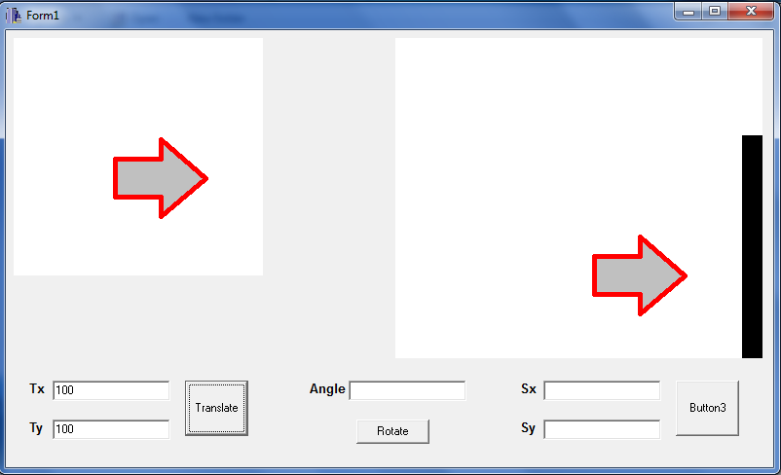

1. **Rotate:**

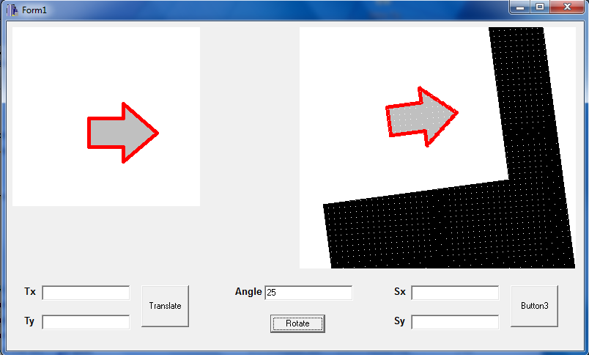

1. **Scale:**

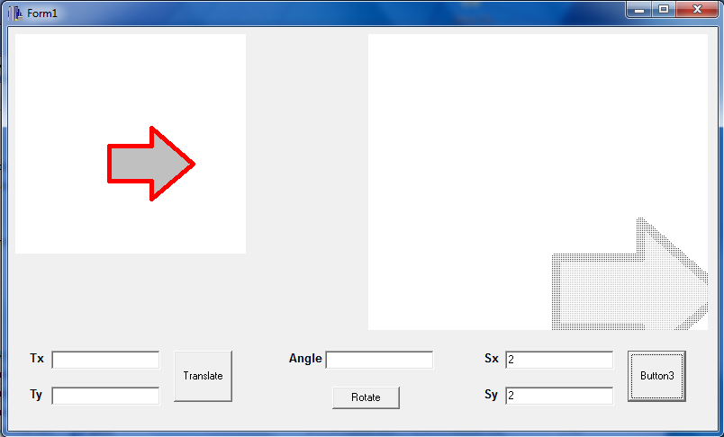

# CONCLUSION:

Hence, the given image was translated, rotated and scaled using C++ builder.